Notes JLH PREZODE 02.11th 2022

400 People.
JLH signed the declaration of intent to support PREZODE for D4A.
- Reminder:
no legal or
financial implications

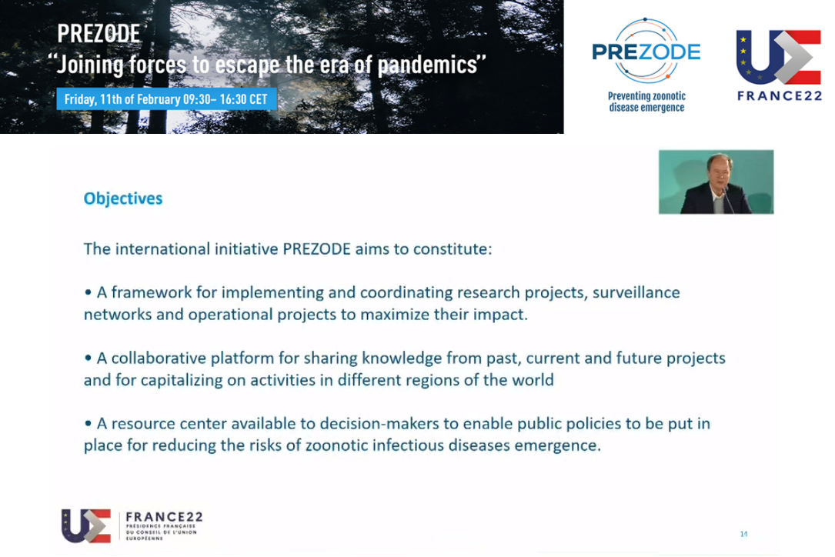

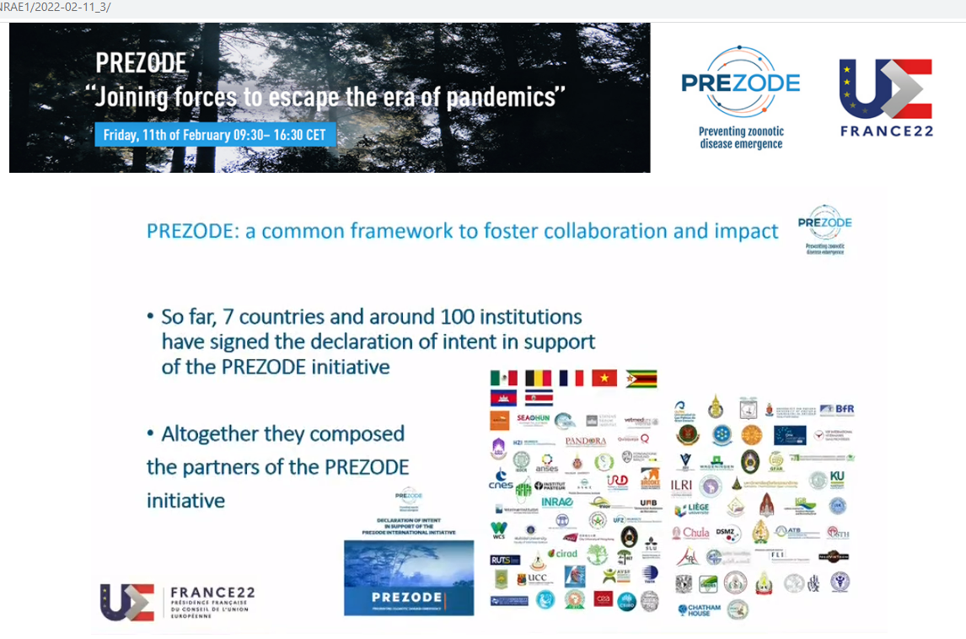

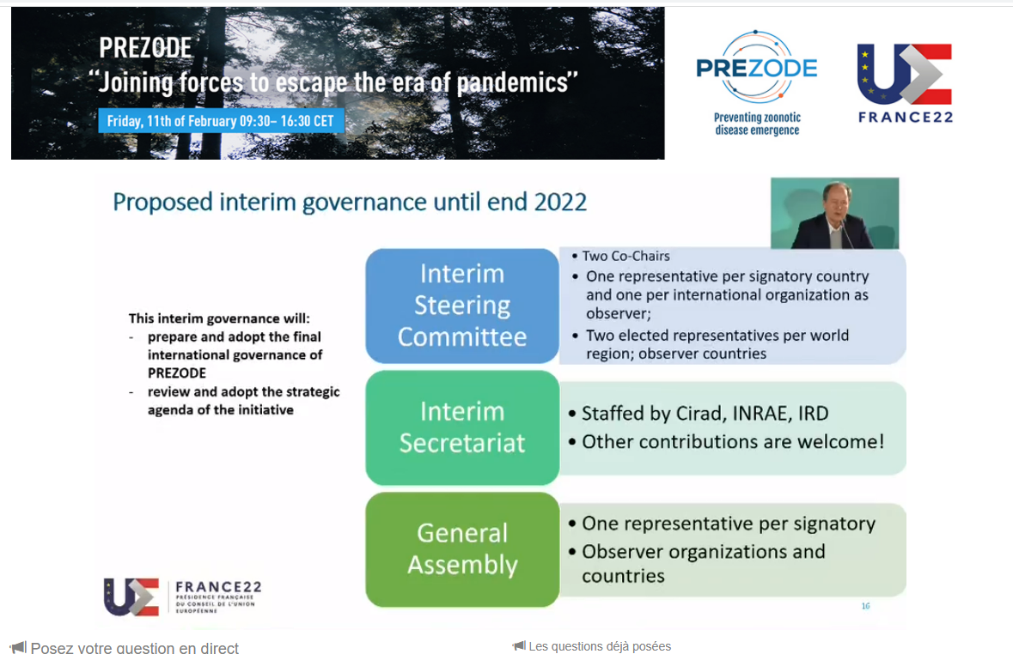

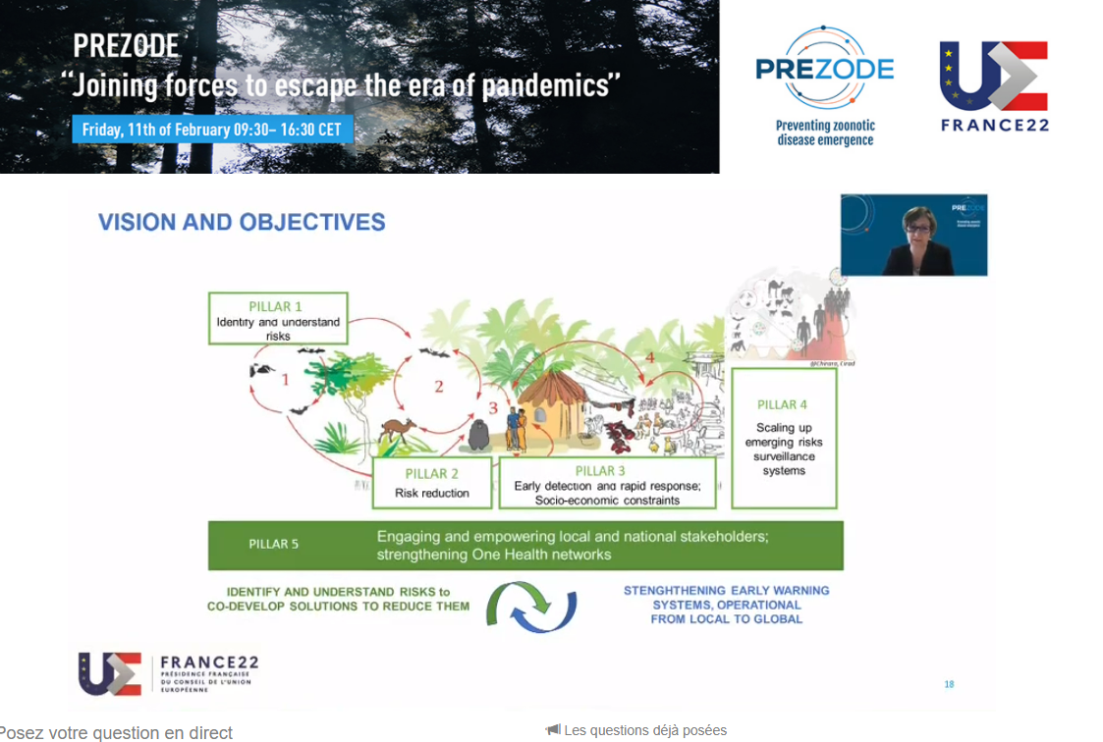
The temporary secretariat is provided by CIRAD INRAe and IRD.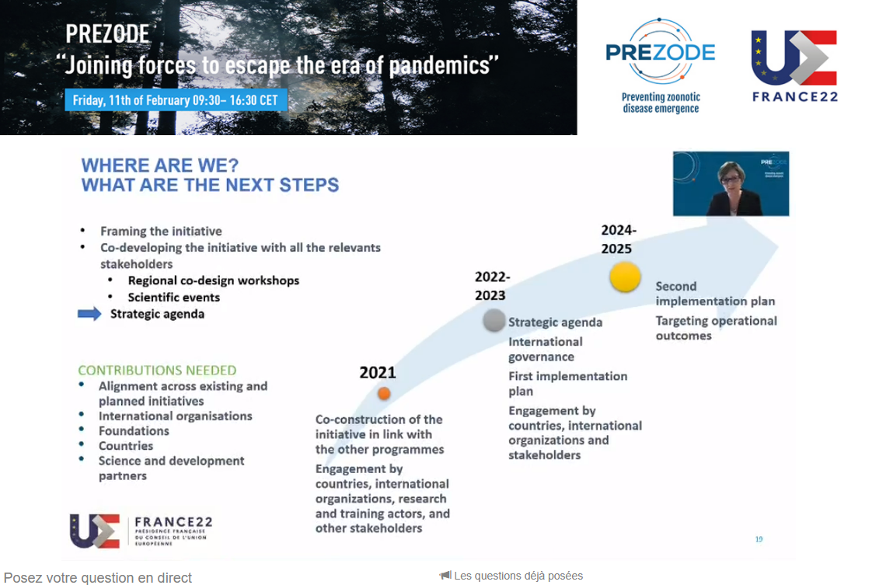

One Health Initiative Philippe MAUGUIN CEO INRAe
- 2 million deaths per year.
- The cost of treatment is 100 times higher than the cost of prevention.
- Transdisciplinary approach: human animal environment
- Continue the EJP one health

